CIS 387 Lab 2 By: Jason Lu & Marco Seman

ACTIVITY #1

2. Use dd command to copy an existing file on the coomputer and named the new file copy.dd

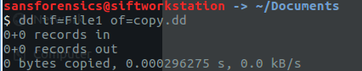

3. Use command md5sum to crate a MD5 hash of the original file and the copied file



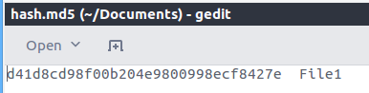



4. Compare the hash of the copied file to the hash of the orginal hash file, confirming both file are the same

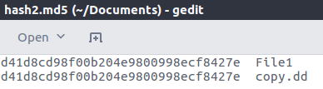

5. Using SHA1 hash commanding to generate the SHA1 hashes

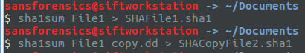

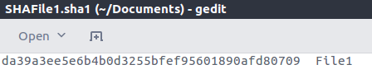

Both hashes of the copied and the original file are the same

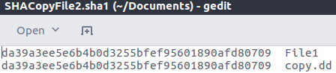

6. Use dd command to copy one block of zero from the dev/zero file

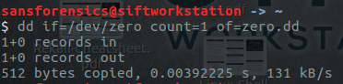

7. After inserting the usb and used mount command, we are able to locate the file under media

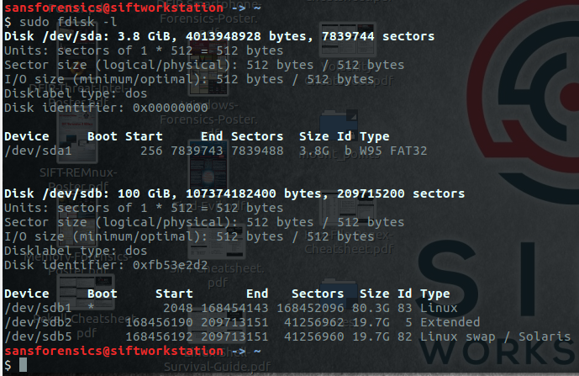

8. Use the command dd to make a full image of the USB

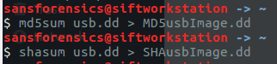

9 & 10. Create both MD5 and SHA1 hashes of the USB

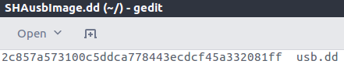

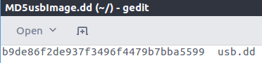

12. Check if the md5 has of the USB flash matches with the md5 hash of the USB image

also check if the sha1 hashes of the USB flash matches with the sha1 hash of the USB image

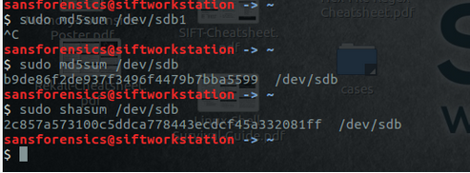

They match

ACTIVITY #2:

1. Open two terimanl, run the command nc –l 888 > ncData.dd on one terminal and on the other terminal run command dd if=./test1 | nc 127.0.0.1.8888
2. We first have to create a test1 file to copy data from the ncData.dd file
3. Check both size of the file are the same

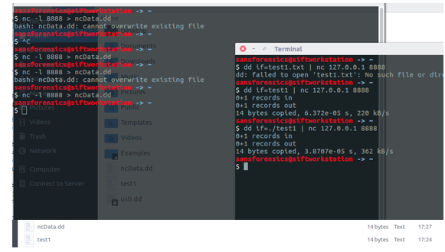

5. Generate the MD5 and SHA1 hashes of ncData.dd and compare them with the original files (test1 file), making sure they are the same

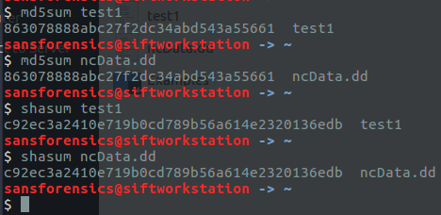

In our second lab, we have learned how to successfully use the dd command to copy and compare files along with learning how to image with netcat over a network goal.

For the first activity, we learned to create a copy of a file using the dd command along with generating an md5 and sh1 hash for those files. Connecting the USB to the virtual machine also took quite some time. For Jason’s laptop (Mac OS) the USB connected easily after installing the USB extension pack. However, for Marco’s laptop (Windows 8.1) there were a few things needed to be changed with the registry settings in order to connected the USB properly to the VM. After connecting the USB properly, we were able to locate the USB by running the command sudo fdisk easily, we learned how to create a copy of a usb using the dd command along with generating a MD5 and SHA hash for both the original USB and the copy USB file.

It took quite some time to generate the MD5 and SHA file from the original USB and we learned that we need to wait longer than 10 minutes for it to generate the hash file since the system goes through a sector by sector approach to generate the hashes.

For the second activity, we learned how to listen to a specific port using nc -l 8888 command. We also learned how to send data from one machine to another using an IP address.